**Project 6 Coin Detection – Part 1 – voting for centers**

Name: _____Joshua Hsueh______________ Period: ________3___ Date: ____4/26/2021_______

Did you name your file l061.cpp (Lower case L, then 061)? __Yes__

Did you create the edge matrix? ____Yes_______

Did you create the gradient direction matrix? __Yes_________

Did you create the imagev.ppm (visual of votes)? __Yes_________

Did you use Bresenham's line algorithm for voting? _Yes__________

Below for the easy image provided paste the imagev.ppm, imageCC.ppm you obtained running your code:

Imagev:

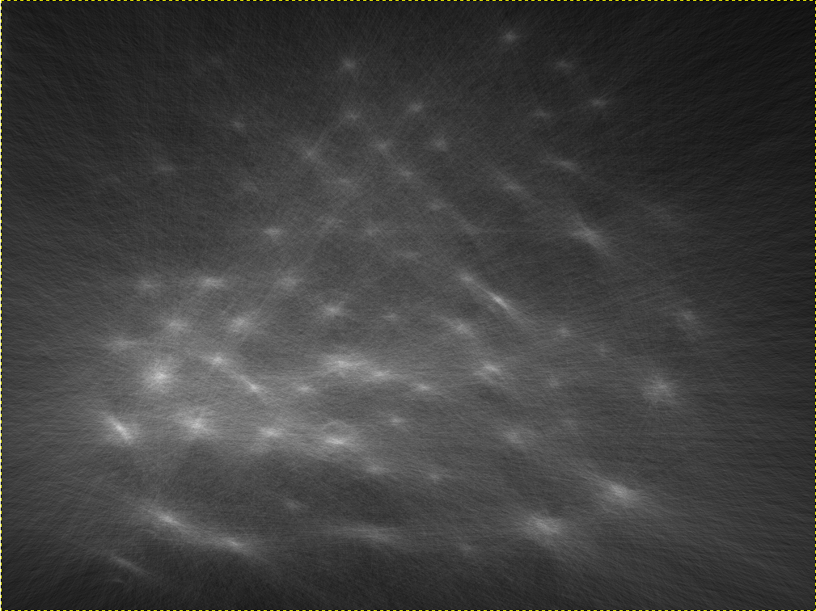

imageCC:

